***The NPM Package Manager and Installing External Node Modules***

**npm:** A package manager for external models that anybody can build.

A package of npm is other modules written by other body. You can add these to uses these packages. Like you are building ledger house and you want trees around your house then you can add tree package.

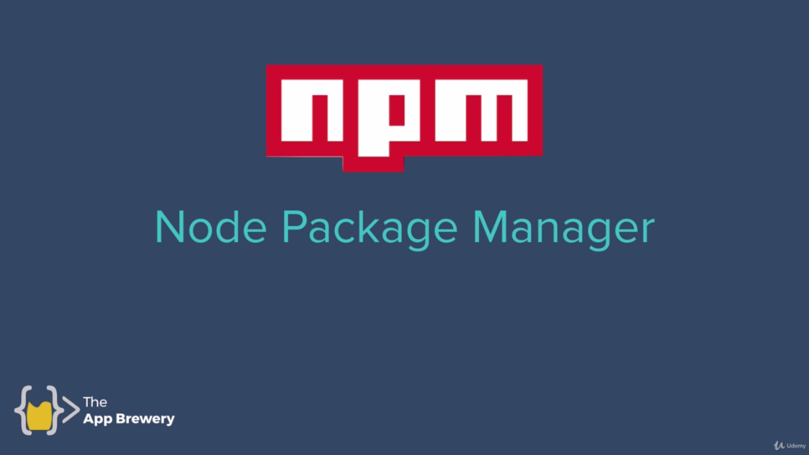

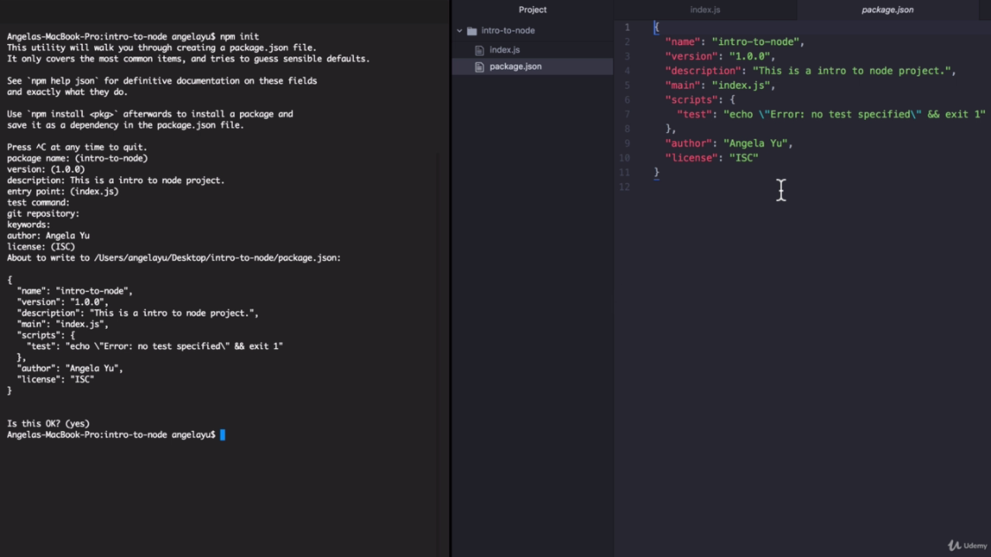

Command **npm init**

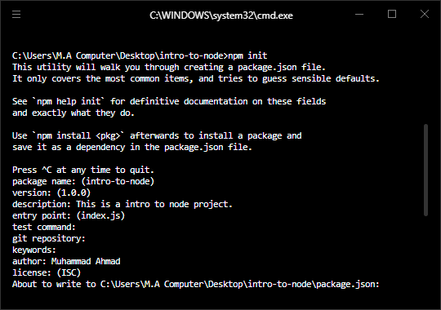

Write description whatever you want.

Author : Your Name

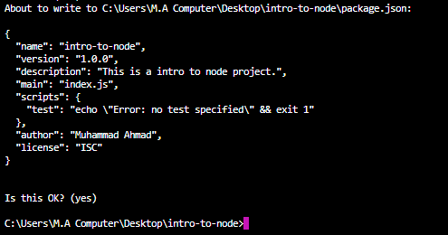

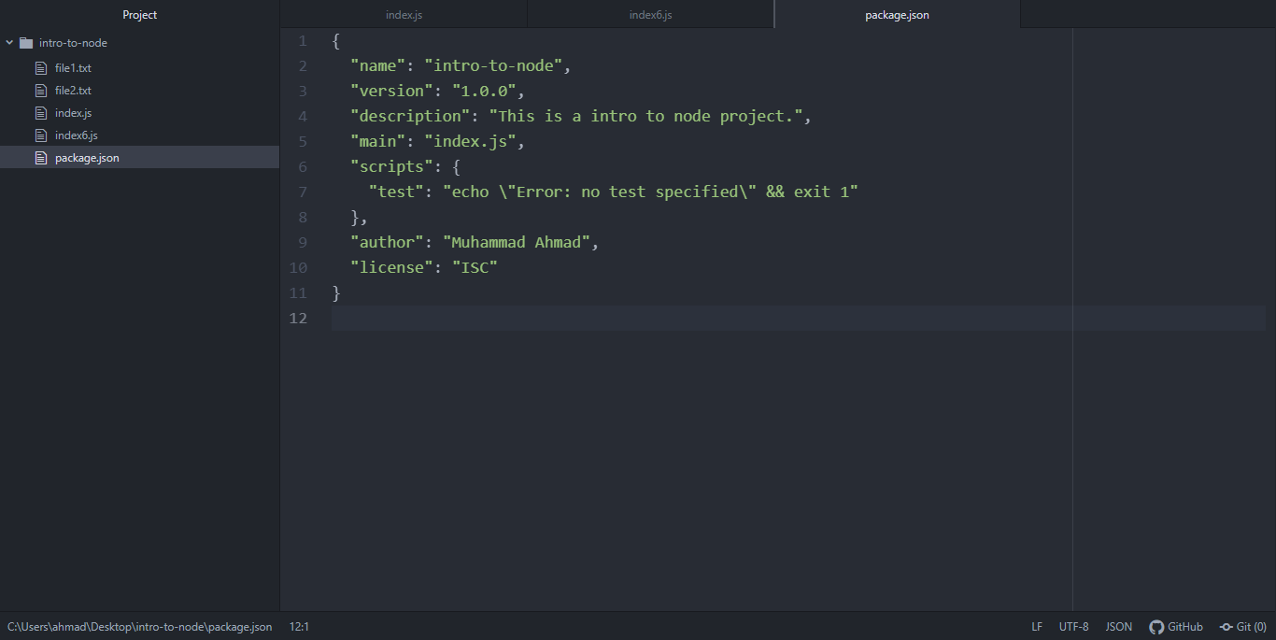

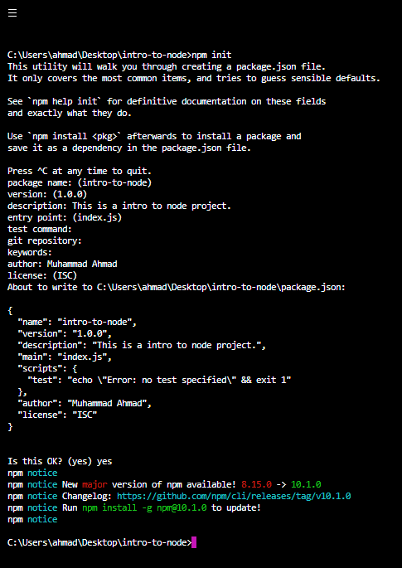

Now package.json is created inside intro-to-node folder.

<https://www.npmjs.com>

<https://www.npmjs.com/package/package>

<https://www.npmjs.com/package/superheroes>

Install just writing the command **npm install superheroes (npm i superheroes)**

Then add usage inside index.js

**var superheroes = require('superheroes');**

**var mySuperheroes = superheroes.random();**

**console.log(mySuperheroes);**

and run in hyper terminal. 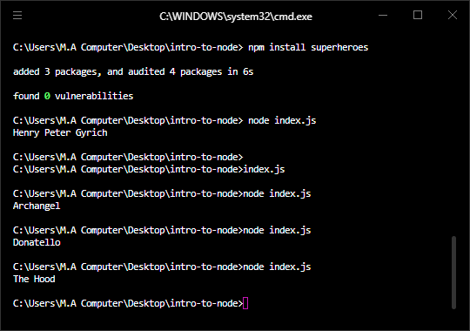

this package is added to generate random super heroes.

**package.json:**

{

"name": "intro-to-node",

"version": "1.0.0",

"description": "This is a intro to node project.",

"main": "index.js",

"scripts": {

"test": "echo \"Error: no test specified\" && exit 1"

},

"author": "Muhammad Ahmad",

"license": "ISC",

"dependencies": {

"superheroes": "^3.0.0"

}

}

**Index.js:**

var superheroes = require('superheroes');

var mySuperheroes = superheroes.random();

console.log(mySuperheroes);

**package-lock.json:**

{

"name": "intro-to-node",

"version": "1.0.0",

"lockfileVersion": 2,

"requires": true,

"packages": {

"": {

"name": "intro-to-node",

"version": "1.0.0",

"license": "ISC",

"dependencies": {

"superheroes": "^3.0.0"

}

},

"node_modules/superheroes": {

"version": "3.0.0",

"resolved": "https://registry.npmjs.org/superheroes/-/superheroes-3.0.0.tgz",

"integrity": "sha512-XXXzeKHMnf0rmZItYkGU803JlqYpoxvxzKFoe6k8C4bolcKfLZH716Rm4DyNJhxPTurbzDEB/QC7TXGsoei+ew==",

"dependencies": {

"unique-random-array": "^2.0.0"

},

"engines": {

"node": ">=8"

}

},

"node_modules/unique-random": {

"version": "2.1.0",

"resolved": "https://registry.npmjs.org/unique-random/-/unique-random-2.1.0.tgz",

"integrity": "sha512-iQ1ZgWac3b8YxGThecQFRQiqgk6xFERRwHZIWeVVsqlbmgCRl0PY13R4mUkodNgctmg5b5odG1nyW/IbOxQTqg==",

"engines": {

"node": ">=6"

}

},

"node_modules/unique-random-array": {

"version": "2.0.0",

"resolved": "https://registry.npmjs.org/unique-random-array/-/unique-random-array-2.0.0.tgz",

"integrity": "sha512-xR87O95fZ7hljw84J8r1YDXrvffPLWN513BNOP4Bv0KcgG5dyEUrHwsvP7mVAOKg4Y80uqRbpUk0GKr8il70qg==",

"dependencies": {

"unique-random": "^2.1.0"

},

"engines": {

"node": ">=8"

}

}

},

"dependencies": {

"superheroes": {

"version": "3.0.0",

"resolved": "https://registry.npmjs.org/superheroes/-/superheroes-3.0.0.tgz",

"integrity": "sha512-XXXzeKHMnf0rmZItYkGU803JlqYpoxvxzKFoe6k8C4bolcKfLZH716Rm4DyNJhxPTurbzDEB/QC7TXGsoei+ew==",

"requires": {

"unique-random-array": "^2.0.0"

}

},

"unique-random": {

"version": "2.1.0",

"resolved": "https://registry.npmjs.org/unique-random/-/unique-random-2.1.0.tgz",

"integrity": "sha512-iQ1ZgWac3b8YxGThecQFRQiqgk6xFERRwHZIWeVVsqlbmgCRl0PY13R4mUkodNgctmg5b5odG1nyW/IbOxQTqg=="

},

"unique-random-array": {

"version": "2.0.0",

"resolved": "https://registry.npmjs.org/unique-random-array/-/unique-random-array-2.0.0.tgz",

"integrity": "sha512-xR87O95fZ7hljw84J8r1YDXrvffPLWN513BNOP4Bv0KcgG5dyEUrHwsvP7mVAOKg4Y80uqRbpUk0GKr8il70qg==",

"requires": {

"unique-random": "^2.1.0"

}

}

}

}

**Challenge Super Villains (supervillains)**

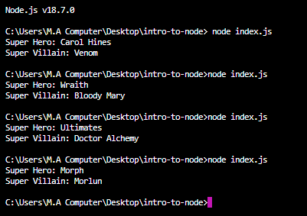

//Super Heroes

var superheroes = require('superheroes');

//Super Villains

var supervillains = require('supervillains');

var mySuperheroes = superheroes.random();

var mySupervillains = supervillains.random();

console.log("Super Hero: "+mySuperheroes);

console.log("Super Villain: "+mySupervillains);

<https://www.npmjs.com/package/supervillains>

install different packages and do practice more and more.